Granger predictability: EURUSD and AUDUSD
Method 13 / daily log returns / p=1 and p=5 / Alpari D1 full available history

Study setup
Logical pair: EURUSD , AUDUSD
Broker symbols: EURUSD_i , AUDUSD_i
Snapshot: 2026-11-03_majors_alpari_D1
Timeframe: D1
Matched return window: 1999-01-05 to 2026-11-02 (UTC bar dates)
Matched return count n: 7201
Dropped unfinished last bar dated 2026-11-03 UTC after a tick-volume check against the prior complete day.
Lag orders pre-specified: p=1 and p=5; both directions
Headline: p=5 joint F test in both directions
Complete matched rows (Excel): EURUSD-AUDUSD_Granger_D1.xlsx
Complete matched rows (HTML table): EURUSD-AUDUSD_Granger_D1_data.html

Method carried forward
Granger predictability asks whether lagged X helps explain Y beyond lags of Y alone on matched daily log returns of close, ln(close_t / close_t-1). Quotes are not inverted. For lag order p, the unrestricted model is y_t on an intercept, y_{t-1}..y_{t-p}, and x_{t-1}..x_{t-p}. The restricted model drops the x lags. The test is an F comparison of residual sums of squares via OLS (numpy.linalg.lstsq) and scipy.stats.f. Orders p=1 and p=5 are pre-specified; both directions are tested. The headline is the p=5 joint test in both directions. p=1 is reported beside it because the guide formula is the one-lag regression. Rejecting H0 is statistical predictability in mean in this sample; it is not economic causation and not a trading signal. There are 56 directed tests at p=5 across the 28 pairs.

Results
direction | p_lags | n | f_stat | p_value | b | df1 | df2
EURUSD_to_AUDUSD | 1 | 7200 | 3.6550228 | 0.05594006 | -0.03522873 | 1 | 7197
EURUSD_to_AUDUSD | 5 | 7196 | 2.766228 | 0.01678918 | nan | 5 | 7185
AUDUSD_to_EURUSD | 1 | 7200 | 0.23350256 | 0.62895351 | 0.00526908 | 1 | 7197
AUDUSD_to_EURUSD | 5 | 7196 | 1.0601476 | 0.38038765 | nan | 5 | 7185

Conclusion
Headline p=5 joint tests for EURUSD and AUDUSD: EURUSD->AUDUSD F=2.7662 (p=0.0167892); AUDUSD->EURUSD F=1.0601 (p=0.380388); usable rows n=7196. One-lag slopes: b_EURUSD->AUDUSD=-0.0352 (F=3.6550, p=0.0559401); b_AUDUSD->EURUSD=0.0053 (F=0.2335, p=0.628954). Rejecting H0 is in-sample mean predictability, not economic cause and not a trading signal.

Charts
Daily closes

Daily log returns

Granger F statistics
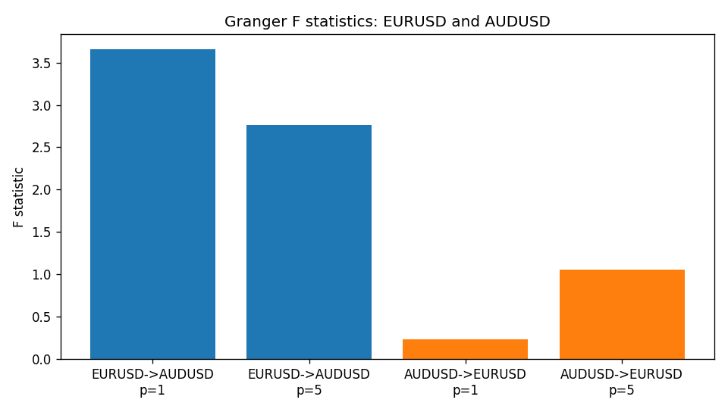

Data report
Every matched row is stored in the sibling Excel workbook named EURUSD-AUDUSD_Granger_D1.xlsx (sheet matched_rows). The results sheet holds the four F tests. Embedding all rows as a Word table is impractical; the Word file holds column summaries and the first and last 15 rows.
Columns: time, EURUSD_open, AUDUSD_open, EURUSD_high, AUDUSD_high, EURUSD_low, AUDUSD_low, EURUSD_close, AUDUSD_close, EURUSD_tick_volume, AUDUSD_tick_volume, EURUSD_spread, AUDUSD_spread, EURUSD_real_volume, AUDUSD_real_volume, EURUSD_log_return, AUDUSD_log_return
Column summaries (matched calculation rows)
column | count | mean | std | min | 25% | 50% | 75% | max
EURUSD_open | 7201 | 1.1813268 | 0.15086382 | 0.8272 | 1.08608 | 1.16615 | 1.29393 | 1.5995
AUDUSD_open | 7201 | 0.75197127 | 0.13525779 | 0.4785 | 0.66105 | 0.73142 | 0.80912 | 1.10284
EURUSD_high | 7201 | 1.1864593 | 0.1514619 | 0.8326 | 1.0902 | 1.17128 | 1.29926 | 1.6038
AUDUSD_high | 7201 | 0.75602178 | 0.13581838 | 0.4878 | 0.6647 | 0.7349 | 0.81518 | 1.10795
EURUSD_low | 7201 | 1.1763142 | 0.15018707 | 0.8227 | 1.08202 | 1.16257 | 1.28834 | 1.5865
AUDUSD_low | 7201 | 0.74791431 | 0.13457219 | 0.4775 | 0.6577 | 0.72758 | 0.8042 | 1.0975
EURUSD_close | 7201 | 1.1813656 | 0.15083992 | 0.8267 | 1.08601 | 1.16617 | 1.29395 | 1.5997
AUDUSD_close | 7201 | 0.75202148 | 0.13524071 | 0.4786 | 0.6612 | 0.73175 | 0.80916 | 1.10169
EURUSD_tick_volume | 7201 | 103004.8 | 173409.64 | 469 | 9389 | 52708 | 99441 | 1471626
AUDUSD_tick_volume | 7201 | 77347.024 | 138135.9 | 109 | 5434 | 43320 | 71320 | 1234623
EURUSD_spread | 7201 | 19.396195 | 16.574381 | 0 | 8 | 12 | 30 | 50
AUDUSD_spread | 7201 | 30.819886 | 16.887485 | 0 | 13 | 30 | 50 | 50
EURUSD_real_volume | 7201 | 4.0238636e+10 | 1.6675367e+11 | 0 | 0 | 0 | 0 | 3.6149665e+12
AUDUSD_real_volume | 7201 | 5.2420906e+09 | 1.2538049e+11 | 0 | 0 | 0 | 0 | 3.811512e+12
EURUSD_log_return | 7201 | -7.54e-06 | 0.00580172 | -0.03123819 | -0.00324684 | 0 | 0.00325501 | 0.03433183
AUDUSD_log_return | 7201 | 2.459e-05 | 0.00754509 | -0.08602525 | -0.00385511 | 0.00028229 | 0.00415126 | 0.0806166
First 15 matched rows (selected columns)
time | EURUSD_close | AUDUSD_close | EURUSD_log_return | AUDUSD_log_return
1999-01-05 | 1.1758 | 0.6215 | -0.0048360507 | -0.00080418179
1999-01-06 | 1.1623 | 0.6289 | -0.011547966 | 0.011836351
1999-01-07 | 1.1712 | 0.6345 | 0.0076280636 | 0.0088650256
1999-01-08 | 1.1585 | 0.6347 | -0.010902799 | 0.00031515916
1999-01-11 | 1.1503 | 0.6393 | -0.007103287 | 0.0072213815
1999-01-12 | 1.1555 | 0.6362 | 0.0045103728 | -0.0048608485
1999-01-13 | 1.1681 | 0.6312 | 0.010845346 | -0.0078902098
1999-01-14 | 1.1681 | 0.6295 | 0 | -0.002696916
1999-01-15 | 1.1563 | 0.634 | -0.010153245 | 0.007123101
1999-01-18 | 1.1605 | 0.6346 | 0.0036256946 | 0.00094592471
1999-01-19 | 1.1603 | 0.6392 | -0.00017235436 | 0.0072225153
1999-01-20 | 1.1566 | 0.64 | -0.0031939256 | 0.0012507819
1999-01-21 | 1.1601 | 0.6405 | 0.0030215416 | 0.00078094498
1999-01-22 | 1.1587 | 0.6327 | -0.0012075213 | -0.012252745
1999-01-25 | 1.1552 | 0.6302 | -0.0030251979 | -0.0039591468
Last 15 matched rows (selected columns)
time | EURUSD_close | AUDUSD_close | EURUSD_log_return | AUDUSD_log_return
2026-10-13 | 1.11965 | 0.69821 | 0.0037402957 | 0.0035007712
2026-10-14 | 1.11545 | 0.69715 | -0.0037582255 | -0.0015193215
2026-10-15 | 1.12172 | 0.69191 | 0.0056053107 | -0.0075447063
2026-10-16 | 1.12371 | 0.69426 | 0.0017724895 | 0.0033906408
2026-10-19 | 1.12086 | 0.6978 | -0.0025394633 | 0.0050859986
2026-10-20 | 1.12354 | 0.70022 | 0.0023881672 | 0.0034620426
2026-10-21 | 1.12318 | 0.70275 | -0.00032046717 | 0.0036066384
2026-10-22 | 1.12139 | 0.70186 | -0.0015949606 | -0.0012672558
2026-10-23 | 1.11989 | 0.70353 | -0.001338521 | 0.0023765656
2026-10-26 | 1.11735 | 0.70128 | -0.0022706559 | -0.0032032829
2026-10-27 | 1.11272 | 0.70245 | -0.004152342 | 0.0016669876
2026-10-28 | 1.1152 | 0.70533 | 0.0022262927 | 0.0040915541
2026-10-29 | 1.11772 | 0.70245 | 0.0022571351 | -0.0040915541
2026-10-30 | 1.11644 | 0.70316 | -0.0011458446 | 0.0010102376
2026-11-02 | 1.11881 | 0.69971 | 0.002120569 | -0.0049184984

